Faceted Data – E-Portfolio Post
Faceted data is an interesting approach to reducing data leakage because it stores or computes different “views” of the same value depending on who is allowed to see it. In Schmitz et al.’s formulation, faceted values present different behaviour according to the observer’s privilege, so an authorised user can see the private value while an unauthorised user only sees the public view. The goal is to enforce noninterference, meaning public outputs should not depend on private inputs. The paper also argues that faceted evaluation can simulate secure multi-execution within a single process, which can improve performance compared with running separate executions for different security levels.
I think this is a good approach in principle, especially for systems where the same data must be shown differently to different users. Its biggest strength is that security is built into the way data is represented, rather than relying only on scattered access-control checks throughout the application. Schmitz et al. also describe a library-based design that supports faceted values, mutable references, and facet-aware communication without modifying the language runtime, which makes the idea more practical.
The main advantages are:
- it gives a strong confidentiality model based on information-flow control
- it can prevent accidental leaks caused by application bugs
- it is well suited to multi-user systems with different visibility levels
- it may be more efficient than full secure multi-execution because it can work in a single process.
The disadvantages are:
- it is conceptually complex and harder to implement than ordinary role-based access control
- it can add overhead in storage, logic, and debugging
- it may be difficult for developers to reason about all facets in a larger system
- related work comparing Multiple Facets with Secure Multi-Execution notes that SME has stronger soundness guarantees, so faceted approaches are not automatically the strongest possible solution in every setting.
Overall, I would say faceted data is useful but not a complete answer on its own. It is best seen as part of a broader security design that also includes authentication, access control, secure logging, encryption, and careful API design. Survey work on information-flow control also shows that leakage prevention techniques must be considered across the application lifecycle, not only at runtime.

Basic Python Outline Design
If I were designing a simple faceted-data system in Python, I would structure it around a small set of classes:
- User
  - stores username and clearance/role
- FacetValue
  - stores public_value, private_value, and a label
- PolicyEngine
  - checks whether a given user is allowed to see a label
- SecureRecord
  - stores fields as FacetValue objects
- Renderer
  - resolves each field into the correct visible value for the current user
- AuditLogger
  - records access attempts and policy decisions

Simple pseudocode

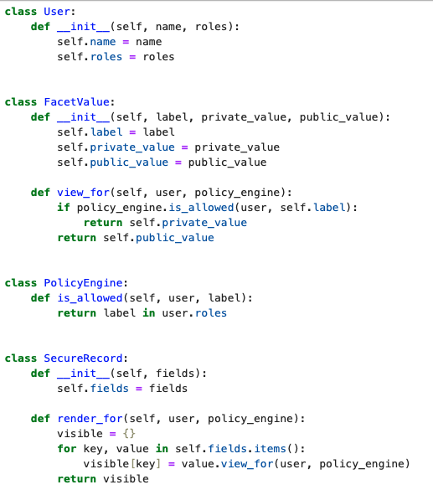
A customer-support system could store:
- email = FacetValue("admin", "asher@example.com", "[hidden]")
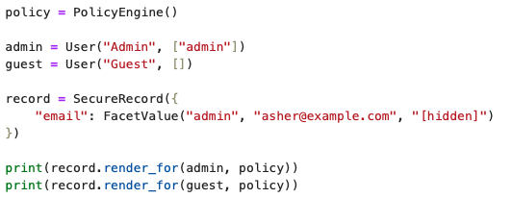
Result:
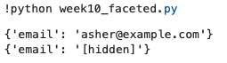
An admin user would see the private email, while a normal user would only see [hidden].

Reflection
This approach is strong for confidentiality because it keeps sensitive and non-sensitive views tied together in one controlled structure. However, the trade-off is complexity. For a real application, I would combine faceted values with simpler controls such as RBAC and validation, rather than relying on faceted data alone.

